**DAILY ONLINE ACTIVITIES SUMMARY**

|  |  |  |  |  |  |  |  |  |
| --- | --- | --- | --- | --- | --- | --- | --- | --- |
| **Date:** | **01-06-2020** | | | | | **Name:** | **Kanaka BS** | |
| **Sem & Sec** | **6th - A** | | | | | **USN:** | **4AL17CS039** | |
| **Online Test Summary** | | | | | | | | |
| **Subject** | | **CNSC-II** | | | | | | |
| **Max. Marks** | | **60** | | **Score** | | | **52** | |
| **Certification Course Summary** | | | | | | | | |
| **Course** | **Complete Python Developer in 2020** | | | | | | | |
| **Certificate Provider** | | | **Udemy** | | **Duration** | | | **30 hours** |
| **Coding Challenges** | | | | | | | | |
| **Problem Statemen:**  **1.**Python Program to remove duplicate elements from a list  2. Java Program to left rotate the elements of an array  3. C Program to find the leaders in the array | | | | | | | | |
| **Status: executed** | | | | | | | | |
| **Uploaded the report in Github** | | | | | **yes** | | | |
| **If yes Repository name** | | | | | <https://github.com/kanakabs/Daily-Status> | | | |
| **Uploaded the report in slack** | | | | | **Yes** | | | |

**ONLINE-TEST-REPORT**

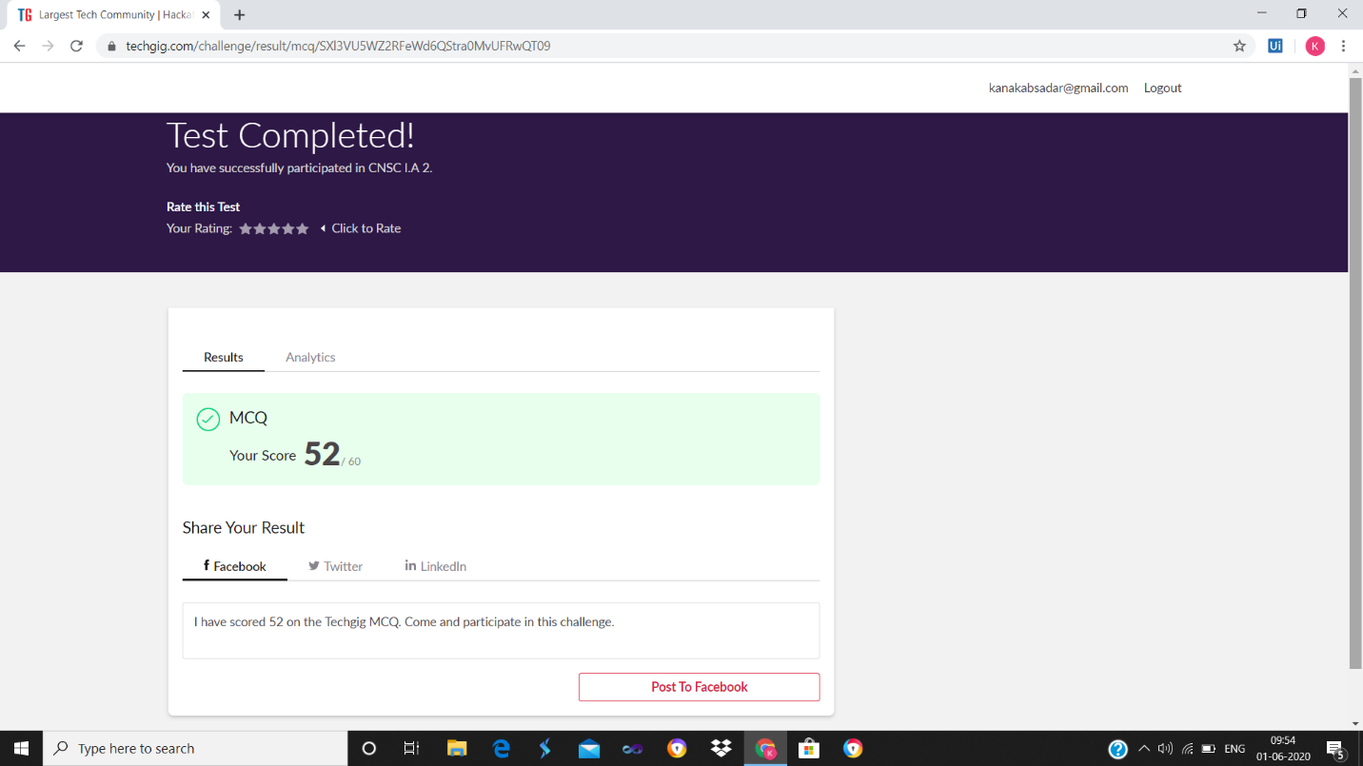

Certification Course Details

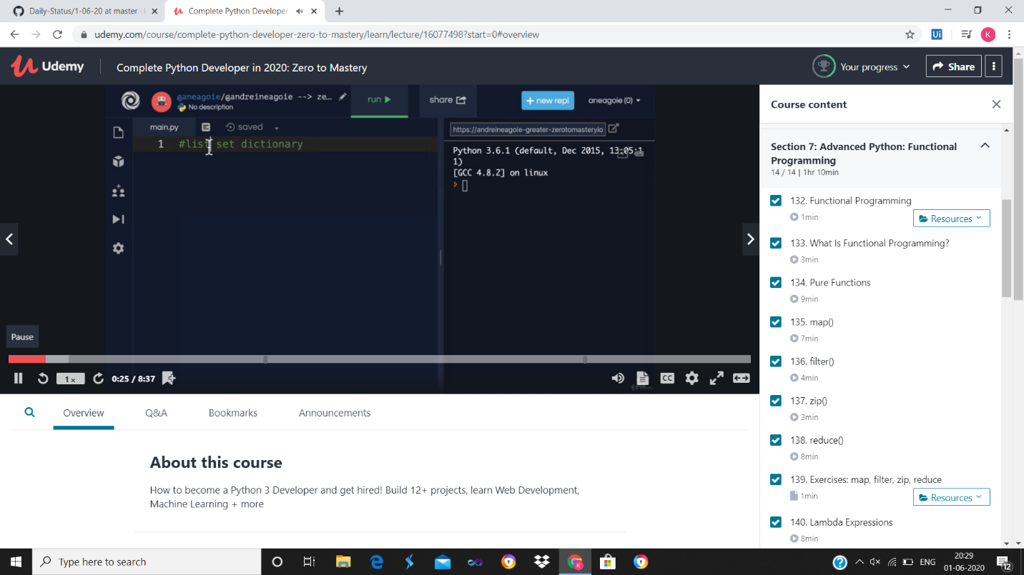

Program output

P-1

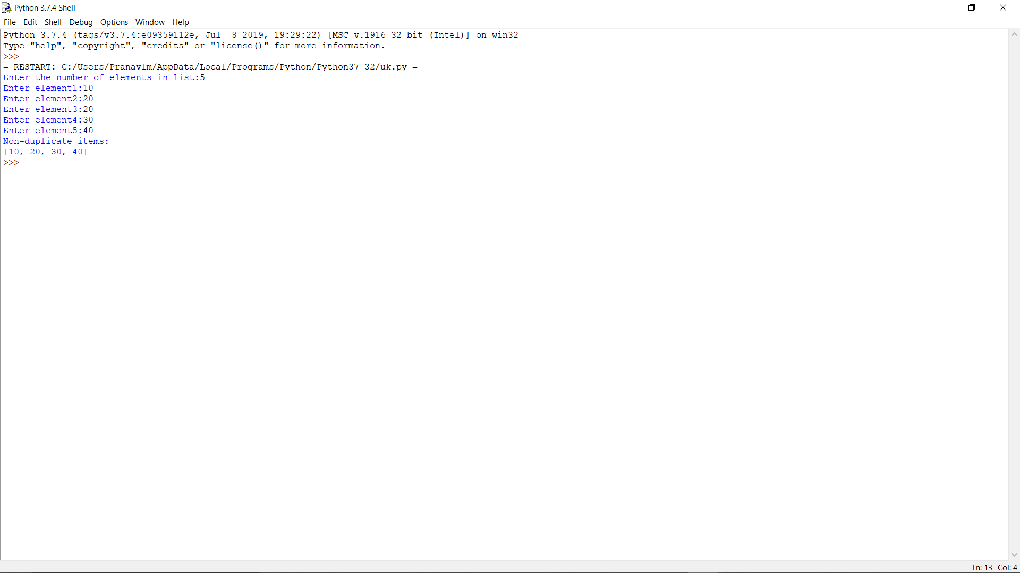

P-2

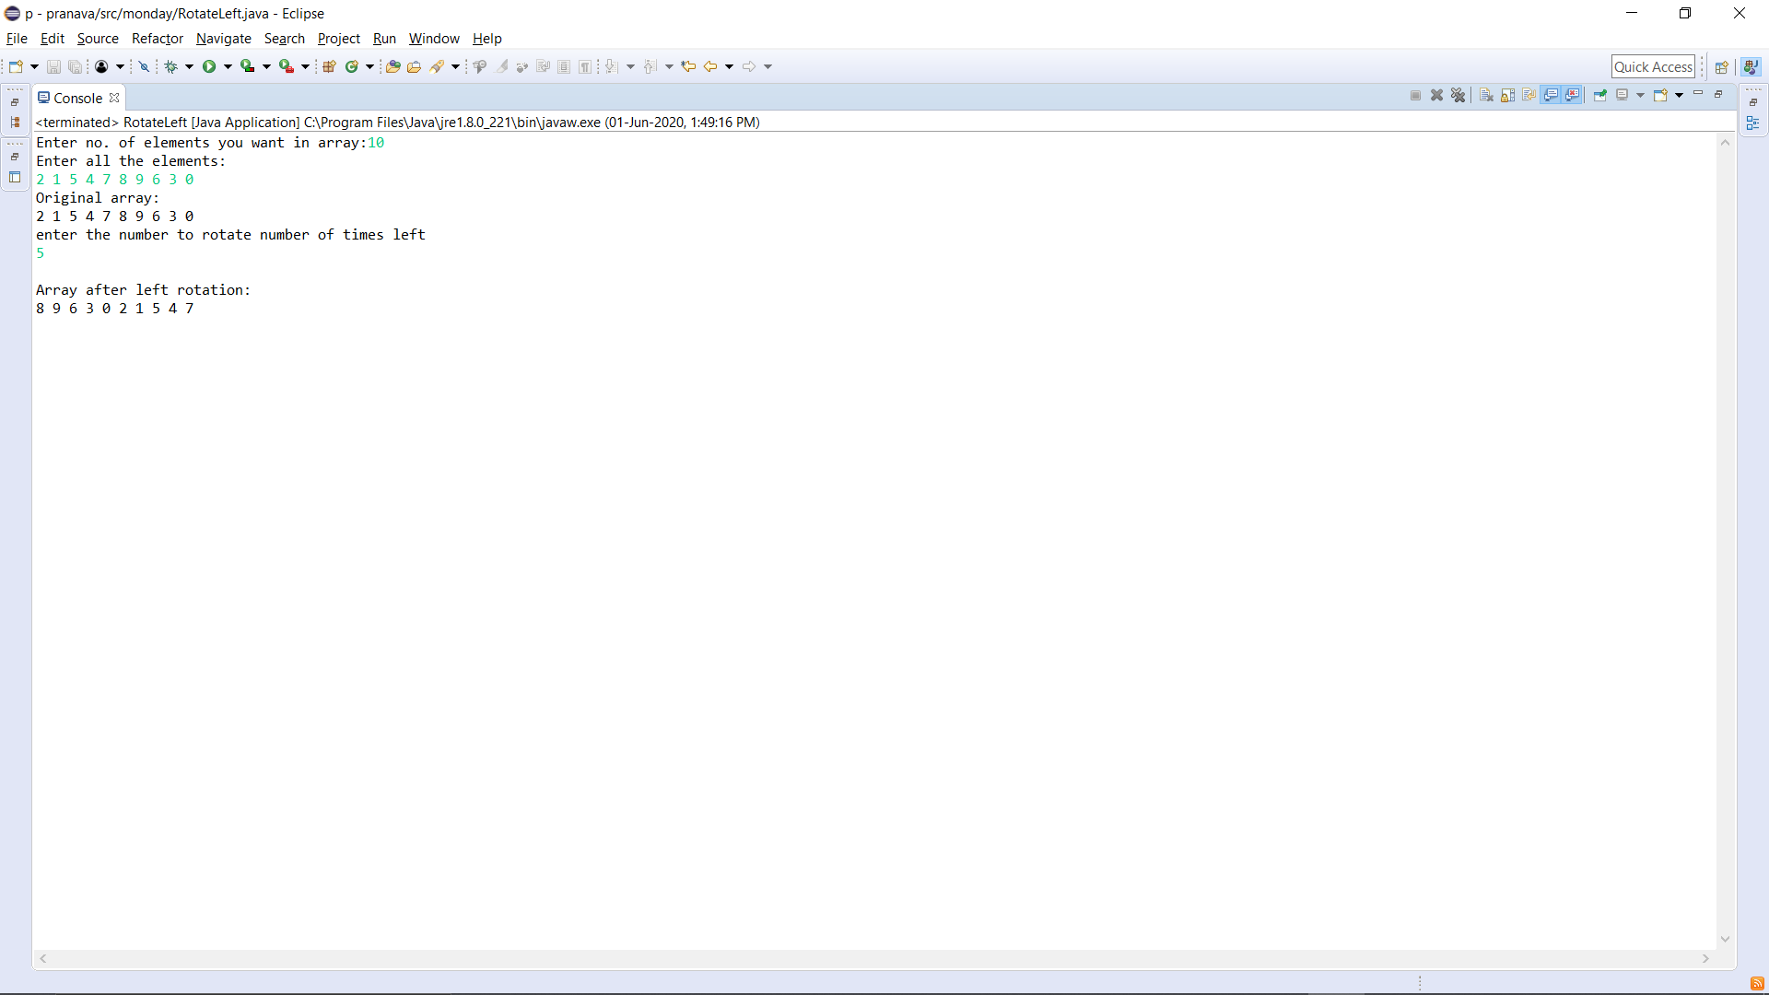

P-3

